-Revenu

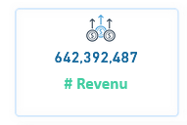

Select Cast(Sum(LineTotal)As decimal(12,0)) As #Revenu

From SQLToturial.dbo.Sales

where Status in('Approved','In Process','Shipped')



-Total Tax

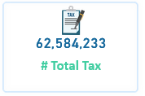

Select Cast(Sum(TaxAmt)As decimal(12,0)) As #Total_Tax

From SQLToturial.dbo.Sales

where Status in('Approved','In Process','Shipped')



-Total Freight

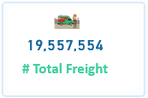

Select Cast(Sum(Freight)As decimal(12,0)) As #Total_Freight

From SQLToturial.dbo.Sales

where Status in('Approved','In Process','Shipped')

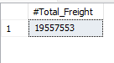

-Total Due

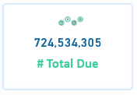

Select Cast(Sum(TotalDue)As decimal(12,0)) As #Total_Due

From SQLToturial.dbo.Sales

where Status in('Approved','In Process','Shipped')

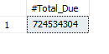

-Orders Days

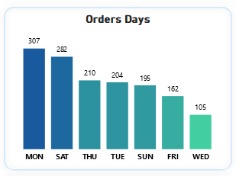

Select {FN DAYNAME(DUEDATE)}AS Days,Count(DISTINCT OrderID)AS Orders

From SQLToturial.dbo.Sales$

Group by DateNAME(DW,DueDate)

order By 2 DESC

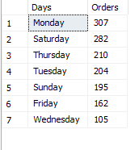

-Order Monthly

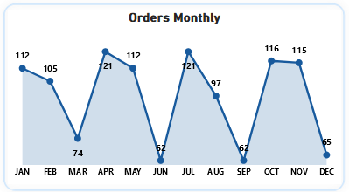

Select Format(DueDate,'MMM')As Monthly,Count(DISTINCT OrderID)AS Orders

From SQLToturial.dbo.Sales$

where Status in('Approved','In Process','Shipped')

Group by Format(DueDate,'MMM')

Order By CASE When Format(DueDate,'MMM') = 'Jan' then 1

When Format(DueDate,'MMM') = 'Feb' then 2

When Format(DueDate,'MMM') = 'Mar' then 3

When Format(DueDate,'MMM') = 'Apr' then 4

When Format(DueDate,'MMM') = 'May' then 5

When Format(DueDate,'MMM') = 'Jun' then 6

When Format(DueDate,'MMM') = 'Jul' then 7

When Format(DueDate,'MMM') = 'Aug' then 8

When Format(DueDate,'MMM') = 'Sep' then 9

When Format(DueDate,'MMM') = 'Oct' then 10

When Format(DueDate,'MMM') = 'Nov' then 11

When Format(DueDate,'MMM') = 'Dec' then 12

Else Null end

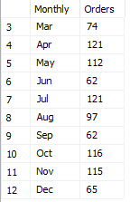

-Orders

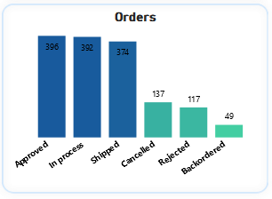

Select Status,Count(DISTINCT OrderID) AS Status

From SQLToturial.dbo.Sales$

group by Status

Order By 2 DESC

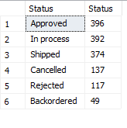

-Revenu By ProductSubCategory

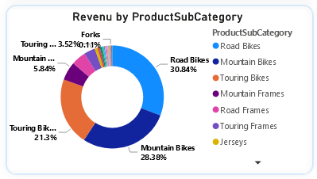

Select DISTINCT ProductSubCategory,Sum(LineTotal) AS Total

, CONCAT(Sum(LineTotal)/( Select Sum(lineTotal)

From SQLToturial.dbo.Sales$

where Status in('Approved','In Process','Shipped'))*100,'%')AS '%OF_Total'

From SQLToturial.dbo.Sales$

where Status in('Approved','In Process','Shipped')

Group by ProductSubCategory

order By 2 DESC

